**1. (50=20+16+14)** Complete the table below for the TCP/IP Reference Model

|  |  |  |
| --- | --- | --- |
| **Name of each layer** | **Names of two major protocols at that layer** | **Name of the unit of information exchanged at that layer** |
| Application Layer | HTTP, POP3 | messages |
| Transport Layer | TCP, UDP | segments |
| Internet Layer | Ip4v, Ip6v | packets |
| Network Access Layer | X.25 , ATM.Ethernet | bits, bytes, cells, frames |

**2. (25=5+10+10)** Complete the table below in relation to **the two most important** differences between virtual circuit (VC) and datagram based packet switching.

|  |  |  |
| --- | --- | --- |
| **Issue ?** | **VC** | **Datagram** |
| 1 Packet delivery to  destination | Guaranteed | Not Guaranteed for datagram of packet switching |
| 2 Packet order at  destination | Guaranteed | Not Guaranteed for circuits of datagram switching |

**3. (25=5+10+10)** About noiseless and noisy communications channels

**(i)** Compute the max data rate possible in a noiseless channel with 20 KHz bandwidth if the signal is binary.

V=2

Capacity in bps = 2*B*log2(V) = 2*(20 KHz)*log2(2) =40 KHz

**(ii)** For the same noiseless channel, what would be the data rate if the signal had 16 levels.

V=16

Capacity in bps = 2 * B * log2 V= 2*(20KHz)*log2(16)= 160KHz

**(iii)** Just write the mathematical equation to compute the signal to noise ratio to transmit a 2048 Kbps digital signal in a noisy communications channelwith 4 MHz bandwidth. Use only numeric values in your expression.

4MHz= 4000*(10^3) KHz

B*log2(1+S/N)= 4000*(10^3) * log2(1+ S/N) = 2048 KHz

1+S/N=2^(11)

**4. (25=10+15)** . Show details of your computation for both parts of the question.

(i) A metallic cable assembly system consists 3 cable segments, each segment with 40dB attenuation, and 2 repeaters (amplifiers) with 35dB gain. Compute the overall attenuation/gain of the cable assembly. Show your work.

**(ii)** If some signal injected into above cable assembly has 30dB signal to noise ratio (SNR) and each cable segment has 5dB SNR and each repeater has 1dB SNR, then what is the SNR of signal at the other end of cable assembly.

**5. (25)** Explain why CDMA performs better (also define what “better” means) than FDM and TDM.

CDMA increases available bandwidth usage. It is based on spread spectrum technology that makes the best use of available bandwidth. It allows every user to always switch across the entire frequency spectrum. CDMA is more efficient than FDM and TDM in XDSL(Digital Subscriber Line). About TDM, the rate of data is low and sharing of bandwidth among different stations takes place.

**6. (50=10+20+20)** In a communications subnet, messages or packets travel from source A to destination D in 3 hops, that is in communication channels A-B, B-C and C-D. Data rate of all three hops is 64Kbps, message size is 32Kbits and the propogation delay per hop is 1 milliseconds.

1. First draw a detailed time-space diagram to show the transmission of a message **from A to B, just one hop**.

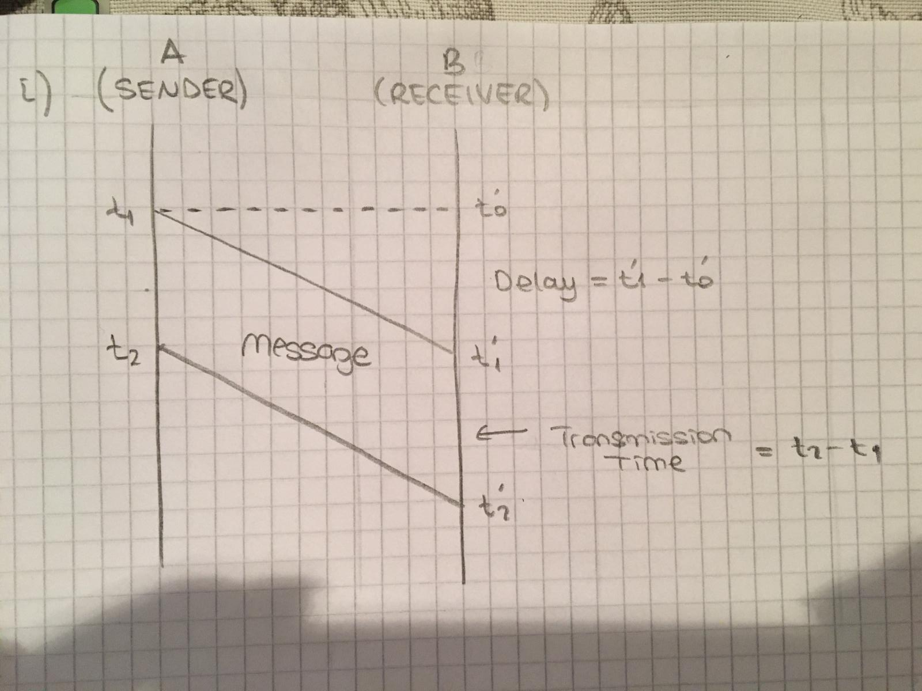

**(Hint: Better draw time-space diagrams** for easier computation for the following two cases.

1. **Compute (by showing your work) the total time to transmit a message from A to D**, if the subnet is Message switched, but ignore message processing times.

Hops is = 3

Tp=L/BW

L=data size, BW=bandwidth

D is delay=1 milisecond

Tp= 32/64=0.5 sec= 500 milisec

500 + 3 =503

3d + 2*d*Tp = 3*(1 milisec) *(500milisec) + 3*(1 milisec)

= 1503 miliseconds

1. **Compute (again by showing your work) the total time to transmit a message from A to D**, if the subnet is datagram based packet switched and packet size is 8 Kbits, again ignore packet processing times.

**Tp=32/64 =0.5 =500 milisec**

**Hops=3**

**d=1milisec**

**,**

**7. (Additional points+20)** What are the discoveries of scientists Maxwell and Hertz?

**Discoveries of Maxwell’s are Electromagnetism, optics and motion of gases.**

**Discoveries of Hertz’s are Radar, radio transmitter.**